Radioactive Tuna: The Hidden Bikini Bombings

Taryn Cail

Hist 1602 Environmental History

Professor Dr Glenn Iceton

November 2024

INTRODUCTION AND THESIS STATEMENT

The possibility of radioactive tuna coming from a fishing boat in Japan, shipped all the way to the US could come from many reasons. But this essay will look at the USA Castle series bomb tests of 1954 and how it may have resulted in radioactive tuna in Japan and California.

SUMMARY OF PRIMARY SOURCE

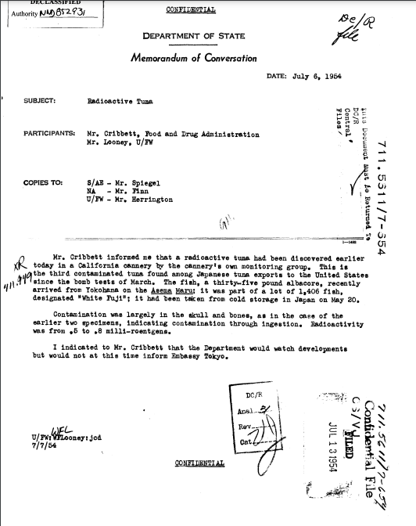

Figure 1

In the given source we find a letter from a W. Flooney to the US Food and Drug Administration with copies being sent to Mr. Cribett, Mr. Looney, Mr. Spiegel, Mr. Finn and Mr. Herrington. The letter details that a Californian cannery discovered a radioactive tuna coming from Yokohoma, Japan from the Asama Maru fishing liner. The fish contained 0.5-0.8 milli-roentgens of radioactivity in it’s skull and bones, which was due to ingestion. The fish was taken from cold storage on May 20th, 1954, and the letter specifies “This is the third contaminated tuna found among Japanese tuna exports to the United States since the bomb tests of March.”. The letter also specifies that the Tokyo Embassy will not be informed of this situation, but continuous monitoring will take place. There is an acute sense of secrecy in the contents of the letter indicating that confidentiality is a must.

CONTEXT

During this time, under a shroud of government confidentiality the US undertook 67 nuclear tests between 1946 and 1958 called the Castle series. (Looking back: No promised Land) The Castle series is the most relevant of these tests as it takes place during the indicated time period of the radioactive tuna, beginning in 1954. (Looking back) The Castle series was a 6 detonation test series in the Spring of 1954 meant to test large-yield thermonuclear hydrogen devices (Castle Series) as well as test to test lithium deuteride as thermonuclear fusion fuel in hydrogen bombs. (Looking back) Within this series there was BRAVO, ROMEO, KOON, UNION, YANKEE and NECTAR. (Castle Series) In order to test the power and efficacy of these devices in the lagoons and archipelago area known as the Marshall Islands. (Castle Series) The Marshal Islands consist of two chains of 29 low-lying coral atolls situated north of the equator between Hawaii and Australia, near where many Japanese fishing liners circulate. (Looking back: No promised Land) Within the Marshal Islands, Bikini Atoll was selected as the main area for detonation. Even though several other nearby islands were inhabited by local indigenous people, the US Army only evacuated Bikini Atoll the rest of the islands and their local inhabitants were left in the dark. (Looking back: No promised Land) Bikini Atoll was settled nearly 2000 years ago by the Bikinian people. (Archaeology….) When the Bikinian people were relocated from their ancestral homes the US Army informed them it was for the “good of mankind.” And that they would be able to return in six months time. (Looking back)

Three days before Castle Bravo was released the winds were predicted to be favorable and no nearby inhabitants were moved other than the Bikinians. Six hours before the detonation, the winds shifted, meaning the fallout would be carried to inhabited islands nearby, despite the risk the US army continued with their tests. (Looking back) Castle Bravo was detonated on schedule March 1st, 1954. It was the first bomb of the series as well as the first deliverable hydrogen bomb and the second largest bomb ever detonated. It decimated 3 of Bikini’s islands and left a crater 2 kilometers wide and 80 meters deep. (Archaeology….) Castle Bravo was 1000 times more powerful than the force of the Hiroshima and Nagasaki bombs. (Looking back: No promised Land)

The mushroom cloud from Castle Bravo was 130,000 feet high and spread 25 miles in diameter in less than 10 minutes. (Looking back) Local inhabitants on nearby Atolls witnessed the fallout and quickly fell ill from radiation poisoning. The fallout of Castle Bravo affected 64 people on Rongerlap Atoll, 18 people on Ailinginae Atoll and 23 members of a nearby Japanese Fishing boat called the Lucky Dragon. (Archaeology….) Despite their sickness, they were only evacuated three days after the detonation. (Looking back)

On June 9, 1954 the American Energy Commission (AEC), downplayed the impact of their nuclear testing to the UN and claimed that no long-term side effects would be felt by locals and that they would be able to return to their homes in six months time. In reality, the locals were exposed to nearly lethal amounts of radiation, equaling to about 60-300 rem and to this day Bikinian locals suffer from chronic illness, displacement, and culture loss because of their relocation. (Looking back)

RADIATION EFFECTS

Hydrogen Bombs when tested on small islands in the ocean vaporize the land and produce radionuclides that settle in the ocean sediment. (Radiation Maps) Contamination levels from long-lied radioactive isotopes and radionuclides such as plutonium and americinium will last for centuries and will forever affect the aquatic environment of these lagoons and surrounding areas. (radiation Maps) The effects of radiation within the ocean are still felt to the present day and many steel ships in the water that aren’t protected gather a low-background amount of radiation in them. Shipwrecks are often dug up from the underseas to use in medical equipment for this reason. (The maritime cultural…)

MEANING/ANALYSIS

These bombings relate to the radioactive tuna because large groups of maturing, juvenile and post spawner fish will migrate across the Pacific Ocean; indicating they could have swam through the danger zone of radiation during the Castle Series testing. (Pacific Bluefin Tuna Migration) As seen in figures 1 and 2 below, the migration routes of Pacific Tuna cross through and around the Marshal Islands, indicating that they could have picked up radiation from the explosion and brought it back to Japan. (Pacific Bluefin Tuna) Castle Bravo was detonated March 1st, 1954, and Castle Romeo on March 27th 1954, these times line up with the letters report suggesting that these bomb testing’s contributed to the radioactive tuna. (Radiation Maps) Upon further investigation divers and researchers found that the most amount of radiation was found within the Castle Bravo crater, further indicating it’s large radioactive contribution to the issue. (Radiation Maps)

Figure 3

Figure 2

CONCLUSION

In conclusion, there is ample evidence to suggest that the Castle series bomb testing, specifically bombs BRAVO and ROMEO, resulted in the radioactive tuna found in California. The matching timelines of the events, the fact that the letter indicates bomb testing and the overlapping migration patterns of pacific tuna, all point towards the Castle series bomb tests. The Castle series testing highlights the profound and far-reaching consequences of nuclear weapons and the devastating effects it has on wildlife. The Castle series serves as a reminder of the ethical and environmental costs of such testing, particularly for vulnerable ecosystems and communities, like the Bikinians who are forever displaced, and their environments will forever be contaminated. The radioactive tuna demonstrates the relationship between human activity and the environment, highlighting the need for caution in military advancements and the need for transparency between people and the government.

BIBLIOGRAPHY

Before WW2 these islands passed hands between Germany and Japan, before finally being taken over by the US in 1944 during WW2. (Looking back: No promised Land)

The US was not the only Country testing it’s bombs, the UK tested in remote inland Australia (1952-1963) and the French tested in Moruroa and Fargataufa (1966-1992) (Archaeology….)

The first bomb tested on Bikini Atoll, before the castle series was Able, detonated on June 30ths, followed by Baker, detonated on July 24. (Looking back)

Bikini means “land of many coconuts”, but since the testing coconut trees struggle to grow and produce minimal fruit. (Archaeology….)

Washout from weather events in shallower regions of the lagoon could affect and decrease the radioactivity. (Radiation Maps)